

**CSE 316**

**Operating System**

**Submmitted by:**

Pankaj prajapati 11706690 REE030B47

1. Consider a scheduling approach which is non pre-emptive similar to shortest job next in nature. The priority of each job is dependent on its estimated run time, and also the amount of time it has spent waiting. Jobs gain higher priority the longer they wait, which prevents indefinite postponement. The jobs that have spent a long time waiting compete against those estimated to have short run times. The priority can be computed as :

= 1 +

Using the data given below compute the waiting time and turnaround time for each process and average waiting time and average turnaround time.

|  |  |
| --- | --- |
| Process | Arrival time |
|  |  |
| P1 | 0 |
|  |  |
| P2 | 5 |
|  |  |
| P3 | 13 |
|  |  |
| P4 | 17 |
|  |  |

**Solution:**

**#include<stdio.h>**

**#include<conio.h>**

**int main()**

**{**

**int n,total=0,bt[30],pid[30],wt[30],tuat[30],pos,temp;**

**float avg_wt,avg_tuat;**

**printf("Enter the number of process:");**

**scanf("%d",&n);**

**printf("\n estimated Time=\n ");**

**for(int i=0;i<n;i++)**

**{**

**printf("p%d:",i+1);**

**scanf("%d",&bt[i]);**

**pid[i]=i+1;**

**}**

**for(int i=0;i<n;i++)**

**{**

**pos=i;**

**for(int j=i+1;j<n;j++)**

**{**

**if(bt[pos]>bt[j])**

**pos=j;**

**}**

**temp=bt[i];**

**bt[i]=bt[pos];**

**bt[pos]=temp;**

**temp=pid[i];**

**pid[i]=pid[pos];**

**pid[pos]=temp;**

**}**

**wt[0]=0;**

**for(int i=1;i<n;i++)**

**{**

**wt[i]=0;**

**for(int j=0;j<i;j++)**

**wt[i]+=bt[j];**

**total+=wt[i];**

**}**

**avg_wt=(float)total/n;**

**total=0;**

**printf("\nProcess\t estimated Time \tWaiting Time \tTurnaround Time");**

**for(int i=0;i<n;i++)**

**{**

**tuat[i]=bt[i]+wt[i]; // turnaround time find out**

**total+=tuat[i];**

**printf("\npid%d\t\t %d\t\t %d\t\t\t%d",pid[i],bt[i],wt[i],tuat[i]);**

**}**

**avg_tuat=(float)total/n; // average turnaround time find out**

**printf("\n\nAverage Waiting Time= %f ",avg_wt);**

**printf("\nAverage Turnaround Time= %f\n ",avg_tuat);**

**}**

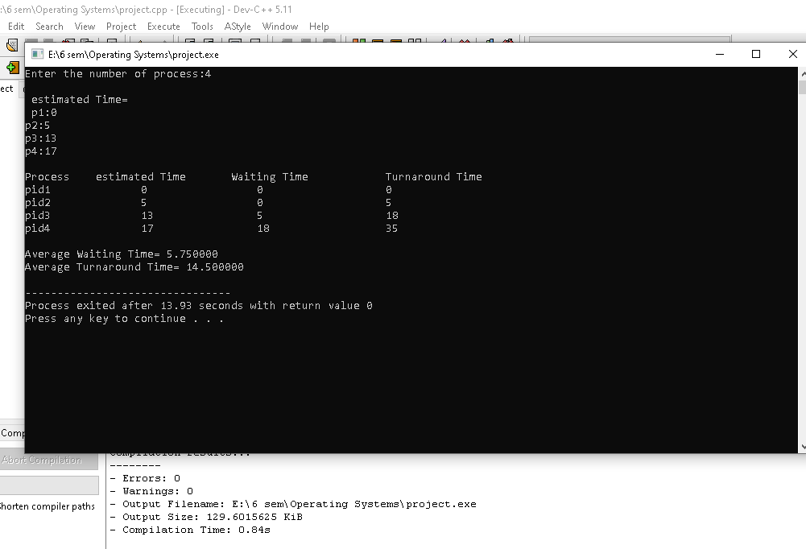

**Take the anther example:**

